**CS-1001L  
Programming Fundamentals**

Quiz Game

Project Reported by  
**Muhammad Haziq (cs201059)**

Group Members:

**Mohib Ismail (cs201063)  
Muhammad Arbaz (cs201068)  
Muhammad Hassan (cs201071)**

Table of Contents

1. *Introduction ____________________________________________ 01*
2. *Goal __________________________________________________ 01*
3. *Scope _________________________________________________ 02*
4. *Features ______________________________________________ 03*
5. *Language and Software Tools _____________________________ 04*
6. *C Code ____________________________________________ 05 - 42*
7. *Screen Shots _______________________________________ 43 – 47*
8. *Task Sheet _____________________________________________ 48*
9. *Flowchart Screenshots ________________________________ 49 - 51*

**Introduction:**

*Managing a time is very important in our life. It is very important to use our time in the right place. We waste most of our time in social media and any other source of internet and instead of benefiting us, it only harms us. It is better to spend our time in something that benefits us and increases our knowledge and sharpen our mind.*

**Goal**

*In the Course of introduction to programming (LAB) in this semester needs us to finish a project and submit using the programming language known as C that we have studied through the course to practice our concepts in the real world applications.*

**Scope:**

*This Quiz Game is very interested for the player and player does not get bored because it is designed such a way that it is very interesting and easy for answer the any question from using single button.*

* *In the beginning there will be a qualifying round and in that round you’ll be asked 3 question which you should must answer correctly. Otherwise you won’t be qualified to the next stage.*
* *Player will check highest points at any time.*
* *If the player need helps, he or she will get it.*
* *The complete Instructions about the game & its rules will be shared before the game starts.*
* *You can also reset the score.*

**Features:**

*There will be two stages this Quiz Game. In the first stage of game, three question will be ask from the user and two answers out of three questions must be given correctly for the player if he or she want to play the second stage otherwise the player will not be eligible for second stage.*

* *Use can play this game at any time and it can play again and again if the user wants.*
* *If the players answers the questions correctly he/she will be awarded with 100 points for each correct answer.*
* *If any user succeeds in achieving all the correct answers he/she will be awarded with $1000.*
* *In the end, there is also a Message with score about your performance*
* *User can view his/her last highest points at any time.*

**Language and Software Tools:**

|  |  |
| --- | --- |
| **Programming Language** | **C** |
| **Operating System** | **Windows 10** |
| **C Compiler** | **TCC** |

**C Code:**

*#include* <stdio.h>

*#include* <conio.h>

*#include* <stdlib.h>

*#include* <time.h>

*#include* <ctype.h>

*void* help();

*void* highestPoint();

*void* scoreReset();

*void* editScore(*int*, *char[]*);

*//*

*int* sports_quiz();

*int* generalKnowledgeQuiz();

*int* generalIslamicQuiz();

*int* generalFoodQuiz();

*int* generalMaths();

*int* programmingLanguage();

*int* main()

{

*int* count1, iSupporter1;

*int* score = 0;

*char* choice;

*char* username[20];

mainhome:

    system("cls");

    printf("\n\n\n\n\n\n\n\n");

    printf("\t\t\t\t\t-------------------------------------");

    printf("\n\t\t\t\t\t======= Welcome To Quiz Game =======\n");

    printf("\t\t\t\t\t-------------------------------------\n\n\n");

    printf("\t\t\t\t\t------------------------------------------------------\n");

    printf("\t\t\t\t\tTo start the game Press 'S'..\n");

    printf("\t\t\t\t\t------------------------------------------------------\n");

    printf("\t\t\t\t\tTo Quit the game Press 'Q'..\n");

    printf("\t\t\t\t\t------------------------------------------------------\n");

    printf("\t\t\t\t\tTo View the Last Highest pints get by user Press 'P'..\n");

    printf("\t\t\t\t\t------------------------------------------------------\n");

    printf("\t\t\t\t\tTo reset the score Press 'R'..\n");

    printf("\t\t\t\t\t------------------------------------------------------\n");

    printf("\t\t\t\t\tTo get the help Press 'H'..\n");

    printf("\t\t\t\t\t------------------------------------------------------\n");

    printf("\n\n\n\n\t\t\t\t\t------------------------------------------------------\n");

    printf("\t\t\t\t\tYour Choice: ");

    choice = toupper(getch());

*switch* (choice)

    {

*case* 'H':

        help();

        getch();

*goto* mainhome;

*break*;

*case* 'Q':

        system("cls");

        printf("\n\n\nExiting the Game....\n\n\n\n\n");

        sleep(3000);

        exit(0);

*case* 'P':

        highestPoint();

        getchar();

*goto* mainhome;

*case* 'R':

        scoreReset();

        getchar();

*goto* mainhome;

*case* 'S':

        system("cls");

        printf("\n\n\n\n\n\n\n\n\n\n\t\t\t\tPlease Enter your Name: ");

        gets(username);

        system("cls");

        printf("____________________________________________\n");

        printf("\n======== Welcome %s to the Game ========\n", username);

        printf("____________________________________________\n\n");

        printf("\nHere are some Tips for you before playing....\n");

        printf("______________________________________________\n\n");

        printf("As you will proceed further you'll be asked three Questions\n");

        printf("out of which 2 should must be given correct else you won't be\n");

        printf("able to play the Game. There are total 6 categories and 1 can\n");

        printf("be selected at a time and after completing the Quiz you'll be\n");

        printf("asked to rather Go to Main home or Again go to Categories and\n");

        printf("select another category and then again play the Game.\n\n");

        printf("You will be given 4 options and you have to\n");

        printf("press A, B ,C or D for right option.\n");

        printf("\n\n_____________________________________________________\n\n");

        printf("If you want to start the game then press 'Y'...\n");

        printf("If you wanna go to HOME screen then press any key...\n");

        printf("_____________________________________________________\n\n");

        printf("What is your Choice: ");

*if* (toupper(getchar()) == 'Y')

        {

            system("cls");

*goto* game;

        }

*else*

        {

*goto* mainhome;

            system("cls");

        }

    game:

        system("cls");

        count1 = 0;

*int* i;

*for* (i = 1; i <= 3; i++)

        {

            system("cls");

            iSupporter1 = i;

*switch* (iSupporter1)

            {

*case* 1:

                printf("\nWhen was the first cricket game played?\n");

                printf("\n\n\tA)19 March 1877\t\tB)20 April 2077\n\n\tC)30 June 1960\t\tD)19 March 1899");

*if* (toupper(getch()) == 'A')

                {

                    printf("\n\nYou selected the Right Answer....\n\n");

                    count1++;

                    getch();

*break*;

                }

*else*

                {

                    printf("\n\nYour Answer is wrong....!");

                    getch();

*break*;

                }

*case* 2:

                printf("\nWhich animal laughs like Human?\n");

                printf("\n\n\tA)Monkey\t\tB)Hyena\n\n\tC)Donkey\t\tD)Chimpanze");

*if* (toupper(getch()) == 'B')

                {

                    printf("\n\nYou selected the Right Answer....\n\n");

                    count1++;

                    getch();

*break*;

                }

*else*

                {

                    printf("\n\nYour Answer is wrong....!");

                    getch();

*break*;

                }

*case* 3:

                printf("\nFirst China war was fought between?\n");

                printf("\n\n\tA)China & Britain\t\tB)China & France\n\n\tC)China % egypt\t\tD)China & Greek");

*if* (toupper(getch()) == 'A')

                {

                    printf("\n\nYou selected the Right Answer....\n\n");

                    count1++;

                    getch();

*break*;

                }

*else*

                {

                    printf("\n\nYour Answer is wrong....!");

                    getch();

*break*;

                }

            }

        }

*if* (count1 >= 2)

        {

*goto* mainGame;

        }

*else*

        {

            system("cls");

            printf("\nYou can't proceed further..!!");

            printf("\nPress any key to go to Main home...\n");

            getch();

*goto* mainhome;

        }

    mainGame:

        system("cls");

        printf("------------------------------------------------\n");

        printf("Welcome %s to the Next Stage of the Game...\n", username);

        printf("------------------------------------------------\n");

        printf("\n----------------------------------------\n");

        printf("What Category would you like to choose? \n");

        printf("----------------------------------------\n");

        printf("\n----------------------------------------------");

        printf("\nPress 'S' to play Sports Quiz");

        printf("\nPress 'G' to play General Knowledge Quiz");

        printf("\nPress 'I' to play Islamic Quiz");

        printf("\nPress 'F' to play General Food Quiz");

        printf("\nPress 'M' to play General Maths Quiz");

        printf("\nPress 'P' to play Programming language Quiz");

        printf("\n----------------------------------------------");

        printf("\nYour Choice: ");

*char* ch;

        ch = toupper(getch());

*switch* (ch)

        {

*case* 'S':

            score = sports_quiz() * 100;

*if* (score >= 0 && score < 600)

            {

                printf("___________________________________\n");

                printf("\nYour Score is: %d", score);

                printf("\nYou didn't perform well in quiz\n");

                printf("___________________________________\n");

*goto* playAgain;

            }

*else* *if* (score >= 600 && score < 1000)

            {

                printf("___________________________________\n");

                printf("\nYou performed Excellent in quiz\n");

                printf("\nYour Score is: %d", score);

                printf("___________________________________\n");

*goto* playAgain;

            }

*else* *if* (score == 1000)

            {

                printf("____________________________________________________________________\n");

                printf("\nYou performed extremely Well and awarded with $1000 by our team...\n");

                printf("\nYour Score is: %d", score);

                printf("____________________________________________________________________\n");

*goto* playAgain;

            }

*break*;

*case* 'G':

            score = generalKnowledgeQuiz() * 100;

*if* (score >= 0 && score < 600)

            {

                printf("___________________________________\n");

                printf("\nYour Score is: %d", score);

                printf("\nYou didn't perform well in quiz\n");

                printf("___________________________________\n");

*goto* playAgain;

            }

*else* *if* (score >= 600 && score < 1000)

            {

                printf("___________________________________\n");

                printf("\nYou performed Excellent in quiz\n");

                printf("\nYour Score is: %d", score);

                printf("___________________________________\n");

*goto* playAgain;

            }

*else* *if* (score == 1000)

            {

                printf("____________________________________________________________________\n");

                printf("\nYou performed extremely Well and awarded with $1000 by our team...\n");

                printf("\nYour Score is: %d", score);

                printf("____________________________________________________________________\n");

*goto* playAgain;

            }

*break*;

*case* 'I':

            score = generalIslamicQuiz() * 100;

*if* (score >= 0 && score < 600)

            {

                printf("___________________________________\n");

                printf("\nYour Score is: %d", score);

                printf("\nYou didn't perform well in quiz\n");

                printf("___________________________________\n");

*goto* playAgain;

            }

*else* *if* (score >= 600 && score < 1000)

            {

                printf("___________________________________\n");

                printf("\nYou performed Excellent in quiz\n");

                printf("\nYour Score is: %d", score);

                printf("___________________________________\n");

*goto* playAgain;

            }

*else* *if* (score == 1000)

            {

                printf("____________________________________________________________________\n");

                printf("\nYou performed extremely Well and awarded with $1000 by our team...\n");

                printf("\nYour Score is: %d", score);

                printf("____________________________________________________________________\n");

*goto* playAgain;

            }

*break*;

*case* 'F':

            score = generalFoodQuiz() * 100;

*if* (score >= 0 && score < 600)

            {

                printf("___________________________________\n");

                printf("\nYour Score is: %d", score);

                printf("\nYou didn't perform well in quiz\n");

                printf("___________________________________\n");

*goto* playAgain;

            }

*else* *if* (score >= 600 && score < 1000)

            {

                printf("___________________________________\n");

                printf("\nYou performed Excellent in quiz\n");

                printf("\nYour Score is: %d", score);

                printf("___________________________________\n");

*goto* playAgain;

            }

*else* *if* (score == 1000)

            {

                printf("____________________________________________________________________\n");

                printf("\nYou performed extremely Well and awarded with $1000 by our team...\n");

                printf("\nYour Score is: %d", score);

                printf("____________________________________________________________________\n");

*goto* playAgain;

            }

*break*;

*case* 'M':

            score = generalMaths() * 100;

*if* (score >= 0 && score < 600)

            {

                printf("___________________________________\n");

                printf("\nYour Score is: %d", score);

                printf("\nYou didn't perform well in quiz\n");

                printf("___________________________________\n");

*goto* playAgain;

            }

*else* *if* (score >= 600 && score < 1000)

            {

                printf("___________________________________\n");

                printf("\nYou performed Excellent in quiz\n");

                printf("\nYour Score is: %d", score);

                printf("___________________________________\n");

*goto* playAgain;

            }

*else* *if* (score == 1000)

            {

                printf("____________________________________________________________________\n");

                printf("\nYou performed extremely Well and awarded with $1000 by our team...\n");

                printf("\nYour Score is: %d", score);

                printf("____________________________________________________________________\n");

*goto* playAgain;

            }

*break*;

*case* 'P':

            score = programmingLanguage() * 100;

*if* (score >= 0 && score < 600)

            {

                printf("___________________________________\n");

                printf("\nYour Score is: %d", score);

                printf("\nYou didn't perform well in quiz\n");

                printf("___________________________________\n");

*goto* playAgain;

            }

*else* *if* (score >= 600 && score < 1000)

            {

                printf("___________________________________\n");

                printf("\nYou performed Excellent in quiz\n");

                printf("\nYour Score is: %d", score);

                printf("___________________________________\n");

*goto* playAgain;

            }

*else* *if* (score == 1000)

            {

                printf("____________________________________________________________________\n");

                printf("\nYou performed extremely Well and awarded with $1000 by our team...\n");

                printf("\nYour Score is: %d", score);

                printf("____________________________________________________________________\n");

*goto* playAgain;

            }

*break*;

*default*:

*goto* mainhome;

        }

    playAgain:

        printf("\n\n\n------------------------------------\n");

        printf("Press Y if you want to play next game");

        printf("\nPress any key if you want to go main menu");

        printf("\n------------------------------------\n");

*if* (toupper(getch()) == 'Y')

*goto* mainGame;

*else*

        {

            editScore(score, username);

*goto* mainhome;

        }

    }

}

*int* sports_quiz()

{

*int* count = 0;

*int* i;

*int* x;

*for* (i = 1; i <= 10; i++)

    {

        system("cls");

        x = i;

*switch* (x)

        {

*case* 1:

            printf("\nQ1.What was total number of matches played in 1975 worldcup?\n");

            printf("\n\n\tA)15\t\tB)18\n\n\tC)20\t\tD)13\n");

*if* (toupper(getch()) == 'A')

            {

                printf("\n\nYou selected the Right Answer....\n\n");

                count++;

                getch();

*break*;

            }

*else*

            {

                printf("\n\nYour Answer is wrong....!\n");

                getch();

*break*;

            }

*case* 2:

            printf("\nQ2.First Olympic game was held in?\n");

            printf("\n\n\tA)England\t\tB)Australia\n\n\tC)Germany\t\tD)Canada\n");

*if* (toupper(getch()) == 'D')

            {

                printf("\n\nYou selected the Right Answer....\n\n");

                count++;

                getch();

*break*;

            }

*else*

            {

                printf("\n\nYour Answer is wrong....!\n");

                getch();

*break*;

            }

*case* 3:

            printf("\nQ3.Which term is commonly used in Badminton & Volley Ball?\n");

            printf("\n\n\tA)Dummy\t\tB)Dribble\n\n\tC)Deuce\t\tD)Double\n");

*if* (toupper(getch()) == 'C')

            {

                printf("\n\nYou selected the Right Answer....\n\n");

                count++;

                getch();

*break*;

            }

*else*

            {

                printf("\n\nYour Answer is wrong....!\n");

                getch();

*break*;

            }

*case* 4:

            printf("\nQ4.If we're using the following words in a game. Which game are we playing?\n");

            printf("\n\nBreak, Cue, In off, jigger, Scratch\n\n");

            printf("\n\n\tA)Polo\t\tB)Billiards\n\n\tC)Bridge\t\tD)Baseball\n");

*if* (toupper(getch()) == 'B')

            {

                printf("\n\nYou selected the Right Answer....\n\n");

                count++;

                getch();

*break*;

            }

*else*

            {

                printf("\n\nYour Answer is wrong....!\n");

                getch();

*break*;

            }

*case* 5:

            printf("\nQ5.Strike word is related to which game?\n");

            printf("\n\n\tA)Baseball\t\tB)Chess\n\n\tC)Cricket\t\tD)Tennis\n");

*if* (toupper(getch()) == 'A')

            {

                printf("\n\nYour Answer is wrong....!\n");

                count++;

                getch();

*break*;

            }

*else*

            {

                printf("Your Answer is wrong....!");

                getch();

*break*;

            }

*case* 6:

            printf("\nQ6.Ronaldo is player of which country?\n");

            printf("\n\n\tA)Brazil\t\tB)Real Madrid\n\n\tC)Portugal\t\tD)Argentina\n");

*if* (toupper(getch()) == 'C')

            {

                printf("\n\nYou selected the Right Answer....\n\n");

                count++;

                getch();

*break*;

            }

*else*

            {

                printf("\n\nYour Answer is wrong....!\n");

                getch();

*break*;

            }

*case* 7:

            printf("\nQ7.When was hockey introduced in Asian games?\n");

            printf("\n\n\tA)1951\t\tB)1958\n\n\tC)1954\t\tD)1962\n");

*if* (toupper(getch()) == 'B')

            {

                printf("\n\nYou selected the Right Answer....\n\n");

                count++;

                getch();

*break*;

            }

*else*

            {

                printf("\n\nYour Answer is wrong....!\n");

                getch();

*break*;

            }

*case* 8:

            printf("\nQ8.Which of the following is the highet Award in Sports in the World?\n");

            printf("\n\n\tA)Arjuna Award\t\tB)Jesse Owens Award\n\n\tC)Dronacharya Award\t\tD)Olympic Order\n");

*if* (toupper(getch()) == 'D')

            {

                printf("\n\nYou selected the Right Answer....\n\n");

                count++;

                getch();

*break*;

            }

*else*

            {

                printf("\n\nYour Answer is wrong....!\n");

                getch();

*break*;

            }

*case* 9:

            printf("\nQ9.Pakistan Cricket Team has won the ODI World cup in?\n");

            printf("\n\n\tA)1999\t\tB)2009\n\n\tC)1992\t\tD)None of the Above\n");

*if* (toupper(getch()) == 'C')

            {

                printf("\n\nYou selected the Right Answer....\n\n");

                count++;

                getch();

*break*;

            }

*else*

            {

                printf("\n\nYour Answer is wrong....!\n");

                getch();

*break*;

            }

*case* 10:

            printf("\nQ10.Which player has scored the fastest ODI century till date?\n");

            printf("\n\n\tA)Shahid Afridi\t\tB)Corey Anderson\n\n\tC)AB Devilliers\t\tD)Chris Gayle\n");

*if* (toupper(getch()) == 'C')

            {

                printf("\n\nYou selected the Right Answer....\n\n");

                count++;

                getch();

*break*;

            }

*else*

            {

                printf("\n\nYour Answer is wrong....!\n");

                getch();

*break*;

            }

        }

    }

*return* count;

}

*int* generalKnowledgeQuiz()

{

*int* count = 0;

*int* i;

*int* x;

*for* (i = 1; i <= 10; i++)

    {

        system("cls");

        x = i;

*switch* (x)

        {

*case* 1:

            printf("\nQ1.Who is the author of 'The myth of Independance'?\n");

            printf("\n\n\tA)Zulfiqar Ali Bhutto\t\tB)Imran Khan party\n\n\tC)Ayesha Jalal\t\tD)Nawaz Sharif\n");

*if* (toupper(getch()) == 'A')

            {

                printf("\n\nYou selected the Right Answer....\n\n");

                count++;

                getch();

*break*;

            }

*else*

            {

                printf("\n\nYour Answer is wrong....!\n");

                getch();

*break*;

            }

*case* 2:

            printf("\nQ2.Famous british physicist Stephen Hawking died at the age of?\n");

            printf("\n\n\tA)86\t\tB)96\n\n\tC)76\t\tD)66\n");

*if* (toupper(getch()) == 'C')

            {

                printf("\n\nYou selected the Right Answer....\n\n");

                count++;

                getch();

*break*;

            }

*else*

            {

                printf("\n\nYour Answer is wrong....!\n");

                getch();

*break*;

            }

*case* 3:

            printf("\nQ3.Which is world's smallest underground lake?\n");

            printf("\n\n\tA)Dragon's Breath Cave\t\tB)Sovetskaya Lake\n\n\tC)Craighead Caverns\t\tD)Moqua Well\n");

*if* (toupper(getch()) == 'D')

            {

                printf("\n\nYou selected the Right Answer....\n\n");

                count++;

                getch();

*break*;

            }

*else*

            {

                printf("\n\nYour Answer is wrong....!\n");

                getch();

*break*;

            }

*case* 4:

            printf("\nQ4.What is the current share of Pakistan in World Population?\n");

            printf("\n\n\tA)2.63%\t\tB)2.30%\n\n\tC)2.40%\t\tD)2.20%\n");

*if* (toupper(getch()) == 'A')

            {

                printf("\n\nYou selected the Right Answer....\n\n");

                count++;

                getch();

*break*;

            }

*else*

            {

                printf("\n\nYour Answer is wrong....!\n");

                getch();

*break*;

            }

*case* 5:

            printf("\nQ5.National predator of Pakistan is?\n");

            printf("\n\n\tA)All of these\t\tB)Lion\n\n\tC)Snow Leopard\t\tD)Snow Bear\n");

*if* (toupper(getch()) == 'C')

            {

                printf("\n\nYour Answer is wrong....!\n");

                count++;

                getch();

*break*;

            }

*else*

            {

                printf("Your Answer is wrong....!");

                getch();

*break*;

            }

*case* 6:

            printf("\nQ6.National Vegetable of Pakistan is?\n");

            printf("\n\n\tA)Potato\t\tB)Carrot\n\n\tC)Lady finger\t\tD)All of these\n");

*if* (toupper(getch()) == 'C')

            {

                printf("\n\nYou selected the Right Answer....\n\n");

                count++;

                getch();

*break*;

            }

*else*

            {

                printf("\n\nYour Answer is wrong....!\n");

                getch();

*break*;

            }

*case* 7:

            printf("\nQ7.FIR stands for?\n");

            printf("\n\n\tA)Fact Interrogation Report\t\tB)First Information Report\n\n\tC)19Final Information Report\t\tD)Field Information Report\n");

*if* (toupper(getch()) == 'B')

            {

                printf("\n\nYou selected the Right Answer....\n\n");

                count++;

                getch();

*break*;

            }

*else*

            {

                printf("\n\nYour Answer is wrong....!\n");

                getch();

*break*;

            }

*case* 8:

            printf("\nQ8.Which Islamic country's National Language is english?\n");

            printf("\n\n\tA)Nigeria\t\tB)Libya\n\n\tC)Somaliya\t\tD)Brunei\n");

*if* (toupper(getch()) == 'A')

            {

                printf("\n\nYou selected the Right Answer....\n\n");

                count++;

                getch();

*break*;

            }

*else*

            {

                printf("\n\nYour Answer is wrong....!\n");

                getch();

*break*;

            }

*case* 9:

            printf("\nQ9.Pakistan's National Game is?\n");

            printf("\n\n\tA)Cricket\t\tB)Hockey\n\n\tC)Football\t\tD)Badminton\n");

*if* (toupper(getch()) == 'B')

            {

                printf("\n\nYou selected the Right Answer....\n\n");

                count++;

                getch();

*break*;

            }

*else*

            {

                printf("\n\nYour Answer is wrong....!\n");

                getch();

*break*;

            }

*case* 10:

            printf("\nQ10.Pakistan's National Anthem was written by?\n");

            printf("\n\n\tA)Hafeez jalandhri\t\tB)Allama Iqbal\n\n\tC)Sir Syed Ahmed Khan\t\tD)Choudhray Brothers\n");

*if* (toupper(getch()) == 'A')

            {

                printf("\n\nYou selected the Right Answer....\n\n");

                count++;

                getch();

*break*;

            }

*else*

            {

                printf("\n\nYour Answer is wrong....!\n");

                getch();

*break*;

            }

        }

    }

*return* count;

}

*int* generalIslamicQuiz()

{

*int* count = 0;

*int* i;

*int* x;

*for* (i = 1; i <= 10; i++)

    {

        system("cls");

        x = i;

*switch* (x)

        {

*case* 1:

            printf("\nQ1. The word Quran literally means?\n");

            printf("\n\n\tA)noble\t\tB)instruction\n\n\tC)recitation\t\tD)direction\n");

*if* (toupper(getch()) == 'C')

            {

                printf("\n\nYou selected the Right Answer....\n\n");

                count++;

                getch();

*break*;

            }

*else*

            {

                printf("\n\nYour Answer is wrong....!\n");

                getch();

*break*;

            }

*case* 2:

            printf("\nQ2.Prophet Muhammad (PBUH) belonged to which family?\n");

            printf("\n\n\tA)Hashmi\t\tB)Quraishi\n\n\tC)Makki\t\tD)Madni\n");

*if* (toupper(getch()) == 'A')

            {

                printf("\n\nYou selected the Right Answer....\n\n");

                count++;

                getch();

*break*;

            }

*else*

            {

                printf("\n\nYour Answer is wrong....!\n");

                getch();

*break*;

            }

*case* 3:

            printf("\nQ3.Which Prophet is called the Father of Muslims�?\n");

            printf("\n\n\tA)prophet Adam (A.S)\t\tB)prophet Ibraheem (A.S)\n\n\tC)prophet Ismaeel (A.S)\t\tD)printf Sulaiman (A.S)\n");

*if* (toupper(getch()) == 'A')

            {

                printf("\n\nYou selected the Right Answer....\n\n");

                count++;

                getch();

*break*;

            }

*else*

            {

                printf("\n\nYour Answer is wrong....!\n");

                getch();

*break*;

            }

*case* 4:

            printf("\nQ4.Which Prophet was able to talk with animals and jinns?");

            printf("\n\n\tA)Prophet Adam (A.S)\t\tB)Prophet Ibraheem (A.S)\n\n\tC)printf Sulaiman (A.S)\t\tD)printf Daniyal (A.S)\n");

*if* (toupper(getch()) == 'C')

            {

                printf("\n\nYou selected the Right Answer....\n\n");

                count++;

                getch();

*break*;

            }

*else*

            {

                printf("\n\nYour Answer is wrong....!\n");

                getch();

*break*;

            }

*case* 5:

            printf("\nQ5. In the Sacrilegious wars”, when Prophet Muhammad (PBUH) was 20 years of age, Quraish and their allies were lead by\n");

            printf("\n\n\tA)Abu Jahal\t\tB)Abu Lahab\n\n\tC)Umayah bin Khalaf\t\tD)Harb bin Umayah\n");

*if* (toupper(getch()) == 'D')

            {

                printf("\n\nYour Answer is wrong....!\n");

                count++;

                getch();

*break*;

            }

*else*

            {

                printf("Your Answer is wrong....!");

                getch();

*break*;

            }

*case* 6:

            printf("\nQ6.Which companion of Prophet (PBUH) was awarded with the title of The sold of Allah�?\n");

            printf("\n\n\tA)Abu Bakr Siddique (R.A)\t\tB)Umar Farooque (R.A)\n\n\tC)Ali Al-Murtaza (R.A)\t\tD)Khalid bin Waleed (R.A)\n");

*if* (toupper(getch()) == 'D')

            {

                printf("\n\nYou selected the Right Answer....\n\n");

                count++;

                getch();

*break*;

            }

*else*

            {

                printf("\n\nYour Answer is wrong....!\n");

                getch();

*break*;

            }

*case* 7:

            printf("\nQ7.What was the name of Imam Bukhari (R.A)?\n");

            printf("\n\n\tA)Muhammad bin Ismaeel\t\tB)Muhammad Ismaeel\n\n\tC)Muhammad Ibraheem\t\tD)Ismaeel bin Ibraheem\n");

*if* (toupper(getch()) == 'A')

            {

                printf("\n\nYou selected the Right Answer....\n\n");

                count++;

                getch();

*break*;

            }

*else*

            {

                printf("\n\nYour Answer is wrong....!\n");

                getch();

*break*;

            }

*case* 8:

            printf("\nQ8.Khateeb-ul-Ambia was the title of\n");

            printf("\n\n\tA)Prophet Dawood (A.S)\t\tB)Prophet Nooh (A.S)\n\n\tC)Prophet Yaqoob (A.S)\t\tD)Prophet Shoaib (A.S)\n");

*if* (toupper(getch()) == 'D')

            {

                printf("\n\nYou selected the Right Answer....\n\n");

                count++;

                getch();

*break*;

            }

*else*

            {

                printf("\n\nYour Answer is wrong....!\n");

                getch();

*break*;

            }

*case* 9:

            printf("\nQ9.________ takes out souls of life bearing creatures.\n");

            printf("\n\n\tA)Jibrael (A.S)\t\tB)Mikael (A.S)\n\n\tC)Israfeel (A.S)\t\tD)Izraeel (A.S)\n");

*if* (toupper(getch()) == 'D')

            {

                printf("\n\nYou selected the Right Answer....\n\n");

                count++;

                getch();

*break*;

            }

*else*

            {

                printf("\n\nYour Answer is wrong....!\n");

                getch();

*break*;

            }

*case* 10:

            printf("\nQ10.The Cave of Hira is in the ________ mountain.\n");

            printf("\n\n\tA)As-Safa\t\tB)Sil\n\n\tC)Uhud\t\tD)An-Noor\n");

*if* (toupper(getch()) == 'D')

            {

                printf("\n\nYou selected the Right Answer....\n\n");

                count++;

                getch();

*break*;

            }

*else*

            {

                printf("\n\nYour Answer is wrong....!\n");

                getch();

*break*;

            }

        }

    }

*return* count;

}

*int* generalFoodQuiz()

{

*int* count = 0;

*int* i;

*int* x;

*for* (i = 1; i <= 10; i++)

    {

        system("cls");

        x = i;

*switch* (x)

        {

*case* 1:

            printf("\nQ1. Which type of beans are used to make baked beans?\n");

            printf("\n\n\tA)Borlotti beans\t\tB)Haricot beans\n\n\tC)Cannellini beans\t\tD)Flageolet beans\n");

*if* (toupper(getch()) == 'B')

            {

                printf("\n\nYou selected the Right Answer....\n\n");

                count++;

                getch();

*break*;

            }

*else*

            {

                printf("\n\nYour Answer is wrong....!\n");

                getch();

*break*;

            }

*case* 2:

            printf("\nQ2.What does IPA stand for?\n");

            printf("\n\n\tA)Intensely potent ale\t\tB)India pale ale\n\n\tC)India premium ale\t\tD)International porter association\n");

*if* (toupper(getch()) == 'B')

            {

                printf("\n\nYou selected the Right Answer....\n\n");

                count++;

                getch();

*break*;

            }

*else*

            {

                printf("\n\nYour Answer is wrong....!\n");

                getch();

*break*;

            }

*case* 3:

            printf("\nQ3.Bobotie is the national dish of which country?\n");

            printf("\n\n\tA)Nigeria\t\tB)Ethiopia\n\n\tC)South Africa\t\tD)Kenya\n");

*if* (toupper(getch()) == 'C')

            {

                printf("\n\nYou selected the Right Answer....\n\n");

                count++;

                getch();

*break*;

            }

*else*

            {

                printf("\n\nYour Answer is wrong....!\n");

                getch();

*break*;

            }

*case* 4:

            printf("\nQ4.Which year did The Great British Bake Off first appear on TV?");

            printf("\n\n\tA)2009\t\tB)2010\n\n\tC)2011\t\tD)2012\n");

*if* (toupper(getch()) == 'B')

            {

                printf("\n\nYou selected the Right Answer....\n\n");

                count++;

                getch();

*break*;

            }

*else*

            {

                printf("\n\nYour Answer is wrong....!\n");

                getch();

*break*;

            }

*case* 5:

            printf("\nQ5. Which of the following does not feature on the ingredients list of Worcestershire Sauce?\n");

            printf("\n\n\tA)Tamarind\t\tB)Anchovies\n\n\tC)Molasses\t\tD)Tomatoes\n");

*if* (toupper(getch()) == 'D')

            {

                printf("\n\nYour Answer is wrong....!\n");

                count++;

                getch();

*break*;

            }

*else*

            {

                printf("Your Answer is wrong....!");

                getch();

*break*;

            }

*case* 6:

            printf("\nQ6. Which of these chocolate bars does not contain nuts in its ingredient list?\n");

            printf("\n\n\tA)Snickers\t\tB)Double Decker\n\n\tC)Picnic\t\tD)Toblerone\n");

*if* (toupper(getch()) == 'B')

            {

                printf("\n\nYou selected the Right Answer....\n\n");

                count++;

                getch();

*break*;

            }

*else*

            {

                printf("\n\nYour Answer is wrong....!\n");

                getch();

*break*;

            }

*case* 7:

            printf("\nQ7.Which flower does the spice saffron come from?\n");

            printf("\n\n\tA)Orchid\t\tB)Crocus\n\n\tC)Nasturtium\t\tD)Poppy\n");

*if* (toupper(getch()) == 'B')

            {

                printf("\n\nYou selected the Right Answer....\n\n");

                count++;

                getch();

*break*;

            }

*else*

            {

                printf("\n\nYour Answer is wrong....!\n");

                getch();

*break*;

            }

*case* 8:

            printf("\nQ8.A Whitby Bun is flavoured with what?\n");

            printf("\n\n\tA)Raspberry\t\tB)Coffee\n\n\tC)Cinnamon\t\tD)Lemon\n");

*if* (toupper(getch()) == 'D')

            {

                printf("\n\nYou selected the Right Answer....\n\n");

                count++;

                getch();

*break*;

            }

*else*

            {

                printf("\n\nYour Answer is wrong....!\n");

                getch();

*break*;

            }

*case* 9:

            printf("\nQ9.Gruy�re is a cheese from which country?\n");

            printf("\n\n\tA)France\t\tB)Switzerland\n\n\tC)Austria\t\tD)Germany\n");

*if* (toupper(getch()) == 'B')

            {

                printf("\n\nYou selected the Right Answer....\n\n");

                count++;

                getch();

*break*;

            }

*else*

            {

                printf("\n\nYour Answer is wrong....!\n");

                getch();

*break*;

            }

*case* 10:

            printf("\nQ10.What are the two main ingredients in the dish Cullen Skink?\n");

            printf("\n\n\tA)Smoked haddock and parsnips\t\tB)Cabbage and potatoes\n\n\tC)Smoked haddock and potatoes\t\tD)Smoked salmon and potatoes\n");

*if* (toupper(getch()) == 'C')

            {

                printf("\n\nYou selected the Right Answer....\n\n");

                count++;

                getch();

*break*;

            }

*else*

            {

                printf("\n\nYour Answer is wrong....!\n");

                getch();

*break*;

            }

        }

    }

*return* count;

}

*int* generalMaths()

{

*int* count = 0;

*int* i;

*int* x;

*for* (i = 1; i <= 10; i++)

    {

        system("cls");

        x = i;

*switch* (x)

        {

*case* 1:

            printf("\nQ1.What is the average of first 150 natural numbers?\n");

            printf("\n\n\tA)70\t\tB)70.5\n\n\tC)75\t\tD)75.5\n");

*if* (toupper(getch()) == 'D')

            {

                printf("\n\nYou selected the Right Answer....\n\n");

                count++;

                getch();

*break*;

            }

*else*

            {

                printf("\n\nYour Answer is wrong....!\n");

                getch();

*break*;

            }

*case* 2:

            printf("\nQ2.0.003 x 0.02 = ?\n");

            printf("\n\n\tA)0.06\t\tB)0.006\n\n\tC)0.0006\t\tD)0.00006\n");

*if* (toupper(getch()) == 'D')

            {

                printf("\n\nYou selected the Right Answer....\n\n");

                count++;

                getch();

*break*;

            }

*else*

            {

                printf("\n\nYour Answer is wrong....!\n");

                getch();

*break*;

            }

*case* 3:

            printf("\nQ3.What is the average of the numbers: 0,0,4,10,5, and 5?\n");

            printf("\n\n\tA)2\t\tB)3\n\n\tC)4\t\tD)5\n");

*if* (toupper(getch()) == 'C')

            {

                printf("\n\nYou selected the Right Answer....\n\n");

                count++;

                getch();

*break*;

            }

*else*

            {

                printf("\n\nYour Answer is wrong....!\n");

                getch();

*break*;

            }

*case* 4:

            printf("\nQ4.|-4| + |4| -4 + 4 = ?\n");

            printf("\n\n\tA)0\t\tB)2\n\n\tC)4\t\tD)8\n");

*if* (toupper(getch()) == 'D')

            {

                printf("\n\nYou selected the Right Answer....\n\n");

                count++;

                getch();

*break*;

            }

*else*

            {

                printf("\n\nYour Answer is wrong....!\n");

                getch();

*break*;

            }

*case* 5:

            printf("\nQ5.If 10 workers can make 10 tables in 10 days, then how many days would it take for 5 workers to make 5 tables?\n");

            printf("\n\n\tA)1\t\tB)5\n\n\tC)10\t\tD)25\n");

*if* (toupper(getch()) == 'C')

            {

                printf("\n\nYour Answer is wrong....!\n");

                count++;

                getch();

*break*;

            }

*else*

            {

                printf("Your Answer is wrong....!");

                getch();

*break*;

            }

*case* 6:

            printf("\nQ6.A parallelogram containing a right angle is called a ?\n");

            printf("\n\n\tA)Square\t\tB)Quadrilateral\n\n\tC)Equilateral\t\tD)Rectangle\n");

*if* (toupper(getch()) == 'D')

            {

                printf("\n\nYou selected the Right Answer....\n\n");

                count++;

                getch();

*break*;

            }

*else*

            {

                printf("\n\nYour Answer is wrong....!\n");

                getch();

*break*;

            }

*case* 7:

            printf("\nQ7.The midpoint of the diameter of a circle is called ?\n");

            printf("\n\n\tA)Chord\t\tB)Center\n\n\tC)Radius\t\tD)Tangent\n");

*if* (toupper(getch()) == 'B')

            {

                printf("\n\nYou selected the Right Answer....\n\n");

                count++;

                getch();

*break*;

            }

*else*

            {

                printf("\n\nYour Answer is wrong....!\n");

                getch();

*break*;

            }

*case* 8:

            printf("\nQ8.An equilateral rectangle is called a?\n");

            printf("\n\n\tA)Quadilateral\t\tB)Square\n\n\tC)Parallelogram\t\tD)Polygon\n");

*if* (toupper(getch()) == 'B')

            {

                printf("\n\nYou selected the Right Answer....\n\n");

                count++;

                getch();

*break*;

            }

*else*

            {

                printf("\n\nYour Answer is wrong....!\n");

                getch();

*break*;

            }

*case* 9:

            printf("\nQ9.What is 1004 divided by 2?\n");

            printf("\n\n\tA)52\t\tB)502\n\n\tC)520\t\tD)5002\n");

*if* (toupper(getch()) == 'B')

            {

                printf("\n\nYou selected the Right Answer....\n\n");

                count++;

                getch();

*break*;

            }

*else*

            {

                printf("\n\nYour Answer is wrong....!\n");

                getch();

*break*;

            }

*case* 10:

            printf("\nQ10.106 x 106 - 94 x 94 = ?\n");

            printf("\n\n\tA)2004\t\tB)2400\n\n\tC)1904\t\tD)1906\n");

*if* (toupper(getch()) == 'B')

            {

                printf("\n\nYou selected the Right Answer....\n\n");

                count++;

                getch();

*break*;

            }

*else*

            {

                printf("\n\nYour Answer is wrong....!\n");

                getch();

*break*;

            }

        }

    }

*return* count;

}

*int* programmingLanguage()

{

*int* count = 0;

*int* i;

*int* x;

*for* (i = 1; i <= 10; i++)

    {

        system("cls");

        x = i;

*switch* (x)

        {

*case* 1:

            printf("\nQ1.What is the only thing computers understand?\n");

            printf("\n\n\tA)Machine Code\t\tB)Low Level Languages\n\n\tC)High Level Languages\t\tD)Algorithms\n");

*if* (toupper(getch()) == 'A')

            {

                printf("\n\nYou selected the Right Answer....\n\n");

                count++;

                getch();

*break*;

            }

*else*

            {

                printf("\n\nYour Answer is wrong....!\n");

                getch();

*break*;

            }

*case* 2:

            printf("\nQ2.A list of instructions that enable a computer to perform a specific task?\n");

            printf("\n\n\tA)Computer Program\t\tB)Algorithm\n\n\tC)Machine Code\t\tD)Bimary Code\n");

*if* (toupper(getch()) == 'A')

            {

                printf("\n\nYou selected the Right Answer....\n\n");

                count++;

                getch();

*break*;

            }

*else*

            {

                printf("\n\nYour Answer is wrong....!\n");

                getch();

*break*;

            }

*case* 3:

            printf("\nQ3.Resolving errors in a program is known as?\n");

            printf("\n\n\tA)Debugging\t\tB)Refixing\n\n\tC)Error Checking\t\tD)Problem Solving\n");

*if* (toupper(getch()) == 'A')

            {

                printf("\n\nYou selected the Right Answer....\n\n");

                count++;

                getch();

*break*;

            }

*else*

            {

                printf("\n\nYour Answer is wrong....!\n");

                getch();

*break*;

            }

*case* 4:

            printf("\nQ4.Which of the following is not a high level programming language?\n");

            printf("\n\n\tA)Assembly\t\tB)C++\n\n\tC)Java\t\tD)Python\n");

*if* (toupper(getch()) == 'A')

            {

                printf("\n\nYou selected the Right Answer....\n\n");

                count++;

                getch();

*break*;

            }

*else*

            {

                printf("\n\nYour Answer is wrong....!\n");

                getch();

*break*;

            }

*case* 5:

            printf("\nQ5.What does binary code means?\n");

            printf("\n\n\tA)a coding system using the binary digits 0 and 1\t\tB)a coding system using the binary digits 1-10\n\n\tC)1000100100\t\tD)code.org\n");

*if* (toupper(getch()) == 'A')

            {

                printf("\n\nYour Answer is wrong....!\n");

                count++;

                getch();

*break*;

            }

*else*

            {

                printf("Your Answer is wrong....!");

                getch();

*break*;

            }

*case* 6:

            printf("\nQ6.What is the smallest unit of measurement used to quantify computer data?\n");

            printf("\n\n\tA)a bride\t\tB)a bit\n\n\tC)marble\t\tD)a tablespoon\n");

*if* (toupper(getch()) == 'B')

            {

                printf("\n\nYou selected the Right Answer....\n\n");

                count++;

                getch();

*break*;

            }

*else*

            {

                printf("\n\nYour Answer is wrong....!\n");

                getch();

*break*;

            }

*case* 7:

            printf("\nQ7.Java,Python,PHP, and C++ are examples of?\n");

            printf("\n\n\tA)low level languages\t\tB)medium level languages\n\n\tC)Graphic arts languages\t\tD)high level languages\n");

*if* (toupper(getch()) == 'D')

            {

                printf("\n\nYou selected the Right Answer....\n\n");

                count++;

                getch();

*break*;

            }

*else*

            {

                printf("\n\nYour Answer is wrong....!\n");

                getch();

*break*;

            }

*case* 8:

            printf("\nQ8.How many bits make up one letter in binary code?\n");

            printf("\n\n\tA)4\t\tB)6\n\n\tC)8\t\tD)10\n");

*if* (toupper(getch()) == 'C')

            {

                printf("\n\nYou selected the Right Answer....\n\n");

                count++;

                getch();

*break*;

            }

*else*

            {

                printf("\n\nYour Answer is wrong....!\n");

                getch();

*break*;

            }

*case* 9:

            printf("\nQ9.Python is a clear and powerful __________-oriented programming languuage?\n");

            printf("\n\n\tA)software\t\tB)object\n\n\tC)snake\t\tD)source\n");

*if* (toupper(getch()) == 'B')

            {

                printf("\n\nYou selected the Right Answer....\n\n");

                count++;

                getch();

*break*;

            }

*else*

            {

                printf("\n\nYour Answer is wrong....!\n");

                getch();

*break*;

            }

*case* 10:

            printf("\nQ10.Which generation of languages started in the 1950s?\n");

            printf("\n\n\tA)First\t\tB)Second\n\n\tC)Third\t\tD)Fourth\n");

*if* (toupper(getch()) == 'C')

            {

                printf("\n\nYou selected the Right Answer....\n\n");

                count++;

                getch();

*break*;

            }

*else*

            {

                printf("\n\nYour Answer is wrong....!\n");

                getch();

*break*;

            }

        }

    }

*return* count;

}

*void* help()

{

    system("cls");

    printf("-------------------------------------------------");

    printf("\n ==================== Help ==================== \n");

    printf("-------------------------------------------------");

    printf("\n\nThere will be a Home Screen in which there are Multiple Options to choose...");

    printf("\nif you want to start the then Press 'S' and the game will start...");

    printf("\nIn the Beginning you'll be asked 3 Questions and you've to answer at least 2 of");

    printf("\nthe questions correctly... If you pass the test then you'll be taken to the next");

    printf("\nlevel of the game and the Menu will appear on your screen and there are 6 categories ");

    printf("\nout there and you can select any category(one at a time) and you can check your");

    printf("\nknowledge about the topic and after the quiz you'll be able to see your score and");

    printf("\nyour performance remarks and after that you'll be asked");

    printf("\nto play again the quiz or go to Main Home...");

    printf("\nIf you want to check the last highest points you scored then there's");

    printf("\na option you can select and check your highest points and if you want");

    printf("\nto somehow reset the score then there's one more option available to reset the ");

    printf("\nscore to 0 and if you want to quit the game then you can Exit it by Pressing 'Q'....\n\n");

}

*void* highestPoint()

{

    system("cls");

*char* name[20] = "Unknown";

*int* score = 0;

    FILE *getScoreAndName;

    getScoreAndName = fopen("result.txt", "r");

    fscanf(getScoreAndName, "%s%d", &name, &score);

    printf("\n\n\t\t*************************************************************");

    printf("\n\n\t\t %s your last Highest Score is: %d", name, score);

    printf("\n\n\t\t*************************************************************");

    fclose(getScoreAndName);

    getch();

}

*void* scoreReset()

{

    system("cls");

    FILE *resetScore;

*int* score = 0;

*char* name[20] = "Unknown";

    resetScore = fopen("result.txt", "w");

    fprintf(resetScore, "%s\t%d", name, score);

    printf("\nSuccessfully Resetted the score...!\n");

    fclose(resetScore);

}

*void* editScore(*int* score, *char* usNm[20])

{

    system("cls");

    FILE *editFile;

*int* scr = score;

    editFile = fopen("result.txt", "w");

    fprintf(editFile, "%s\t%d", usNm, scr);

    fclose(editFile);

}

**Screen shots**

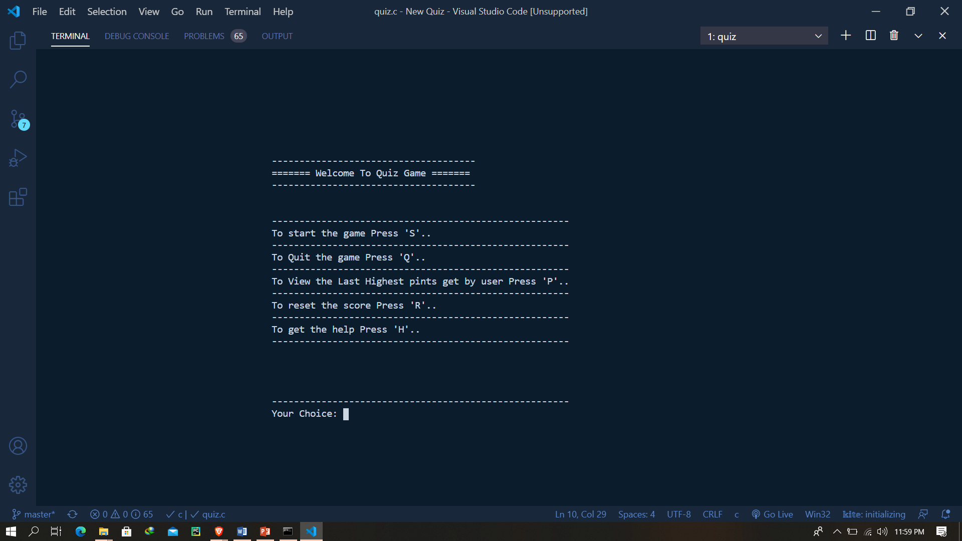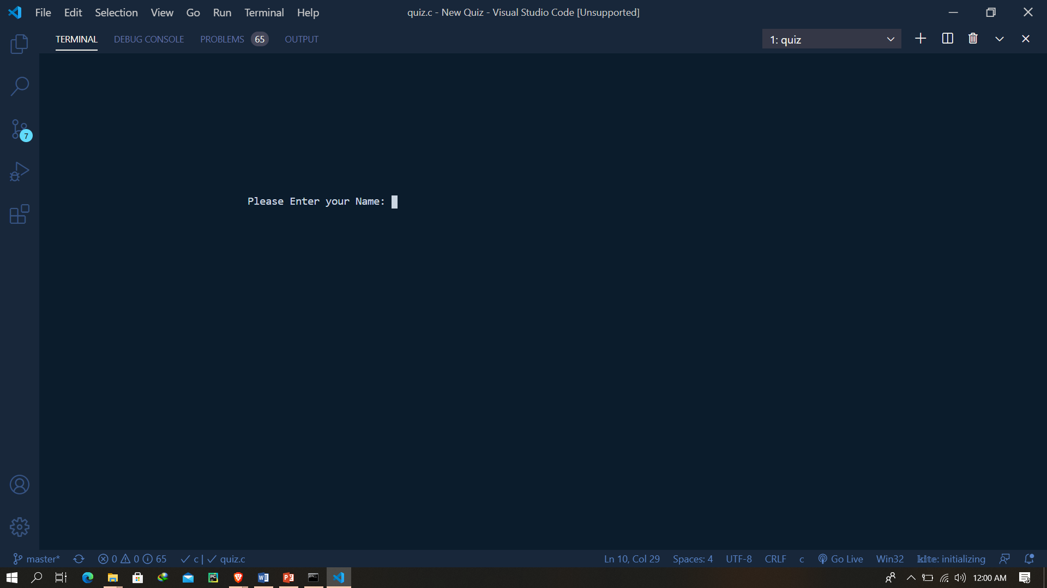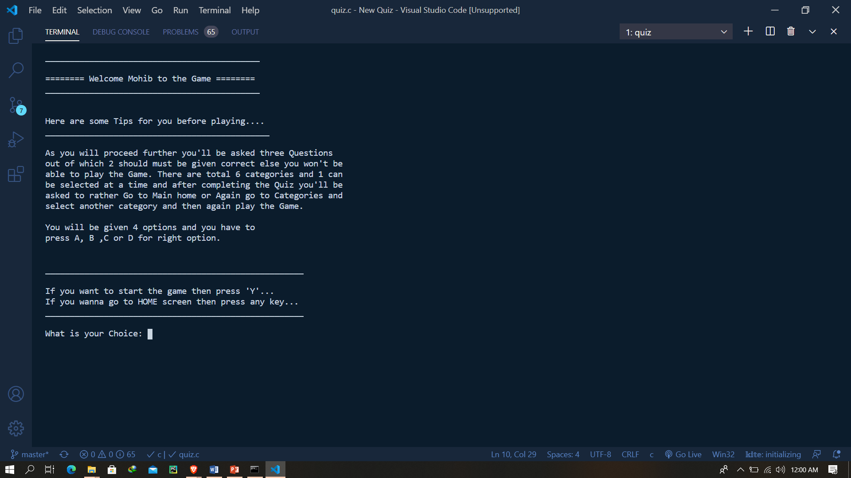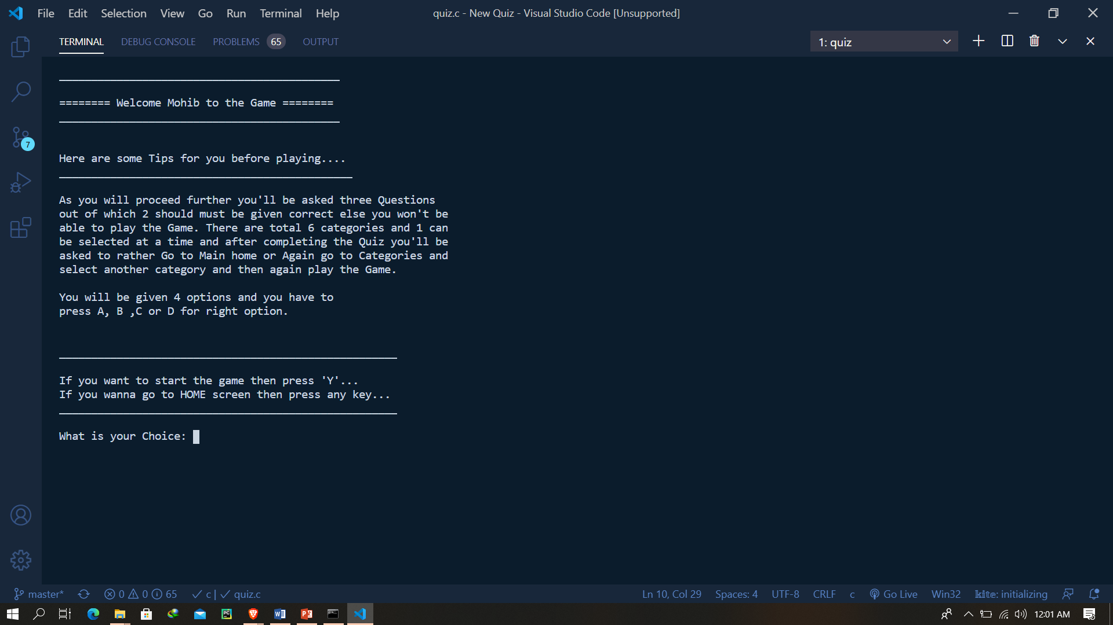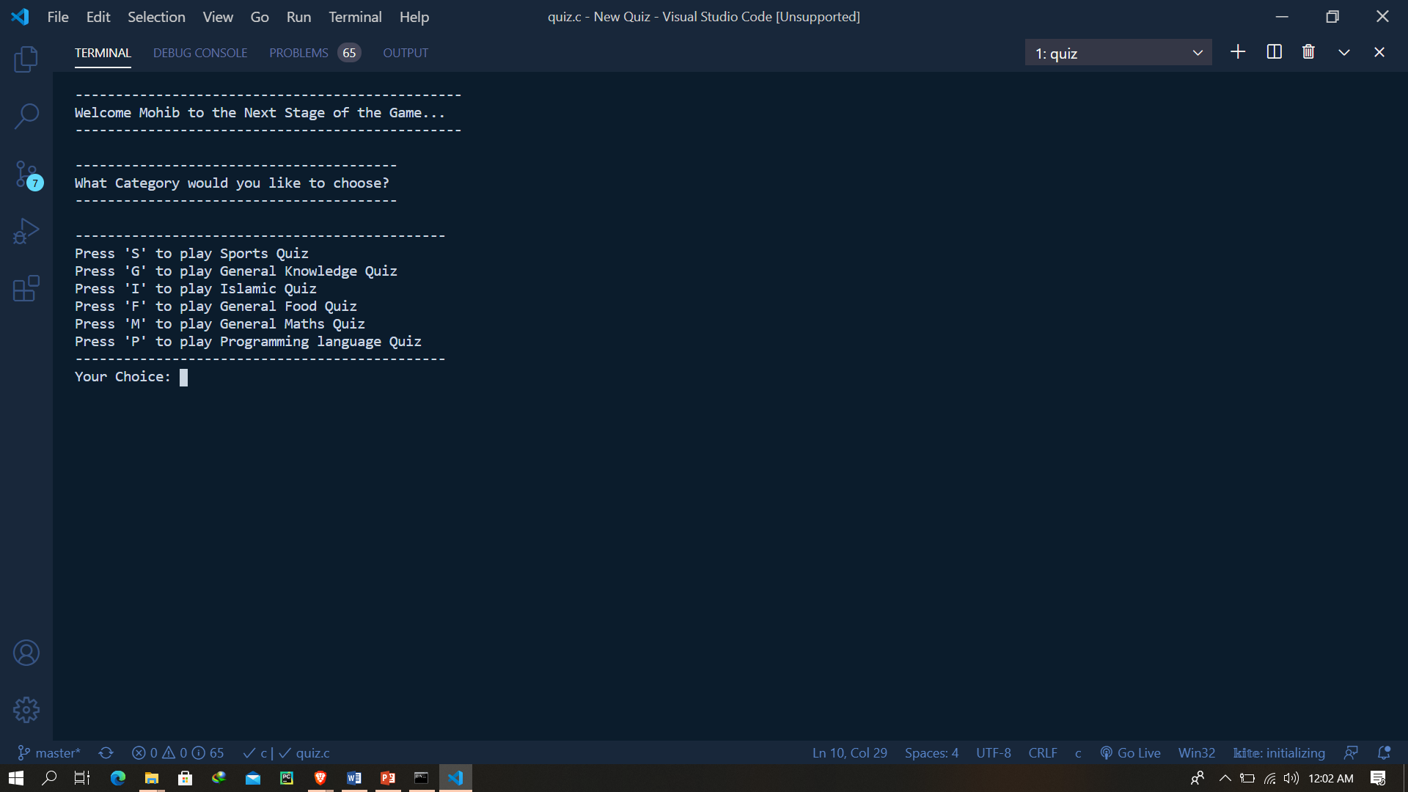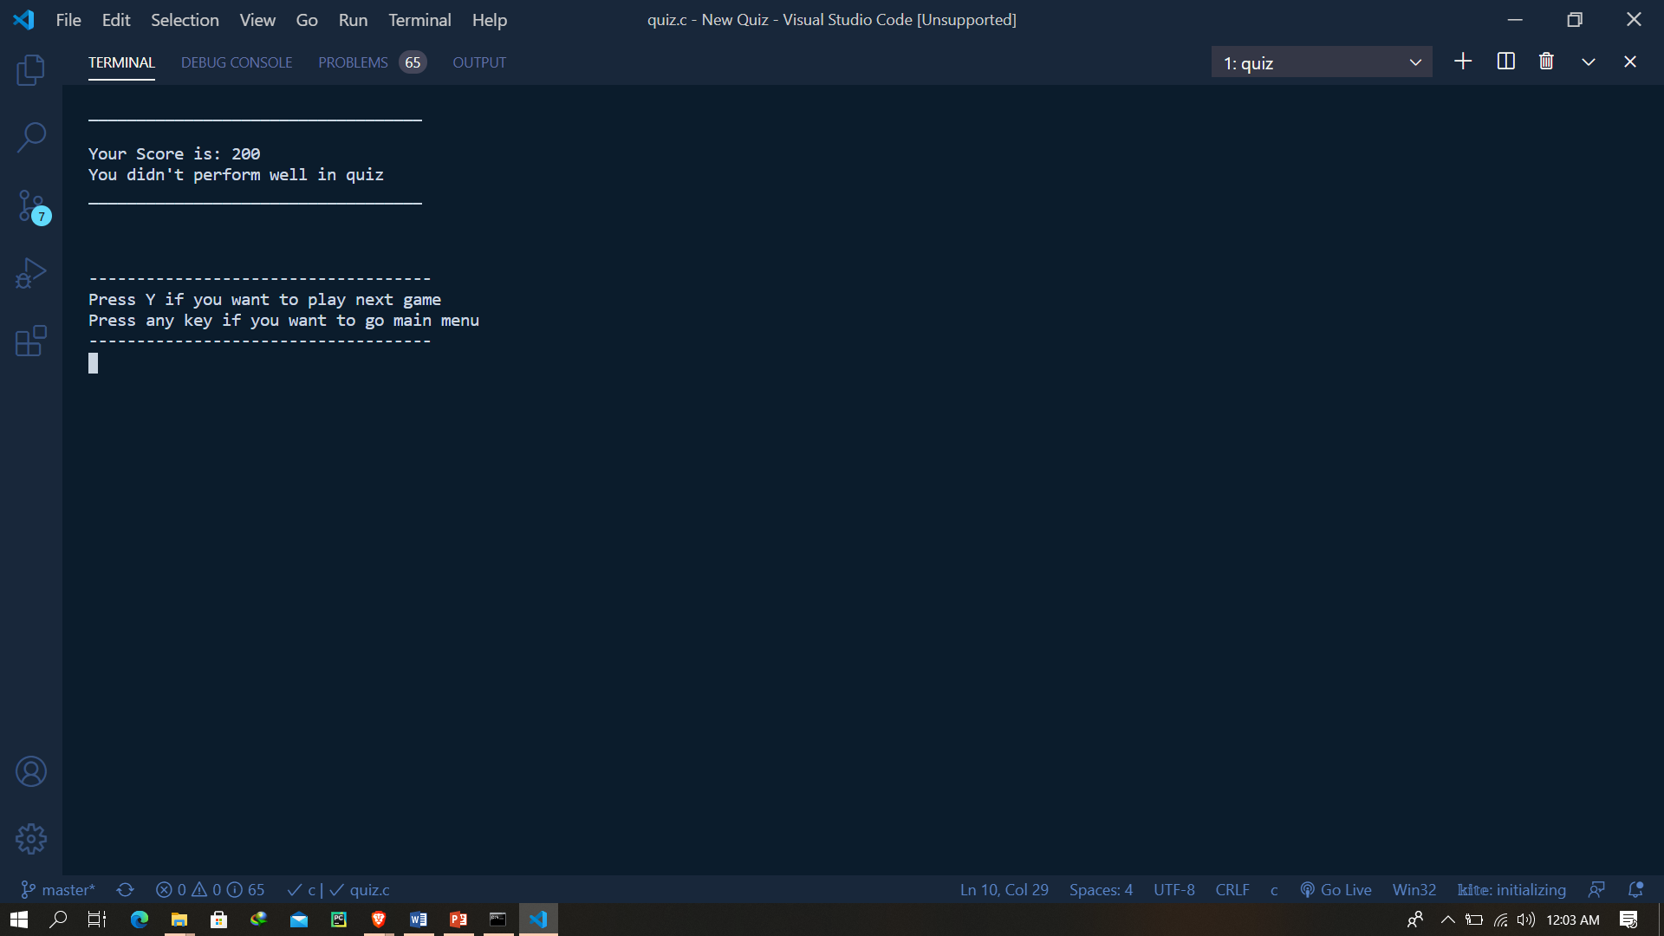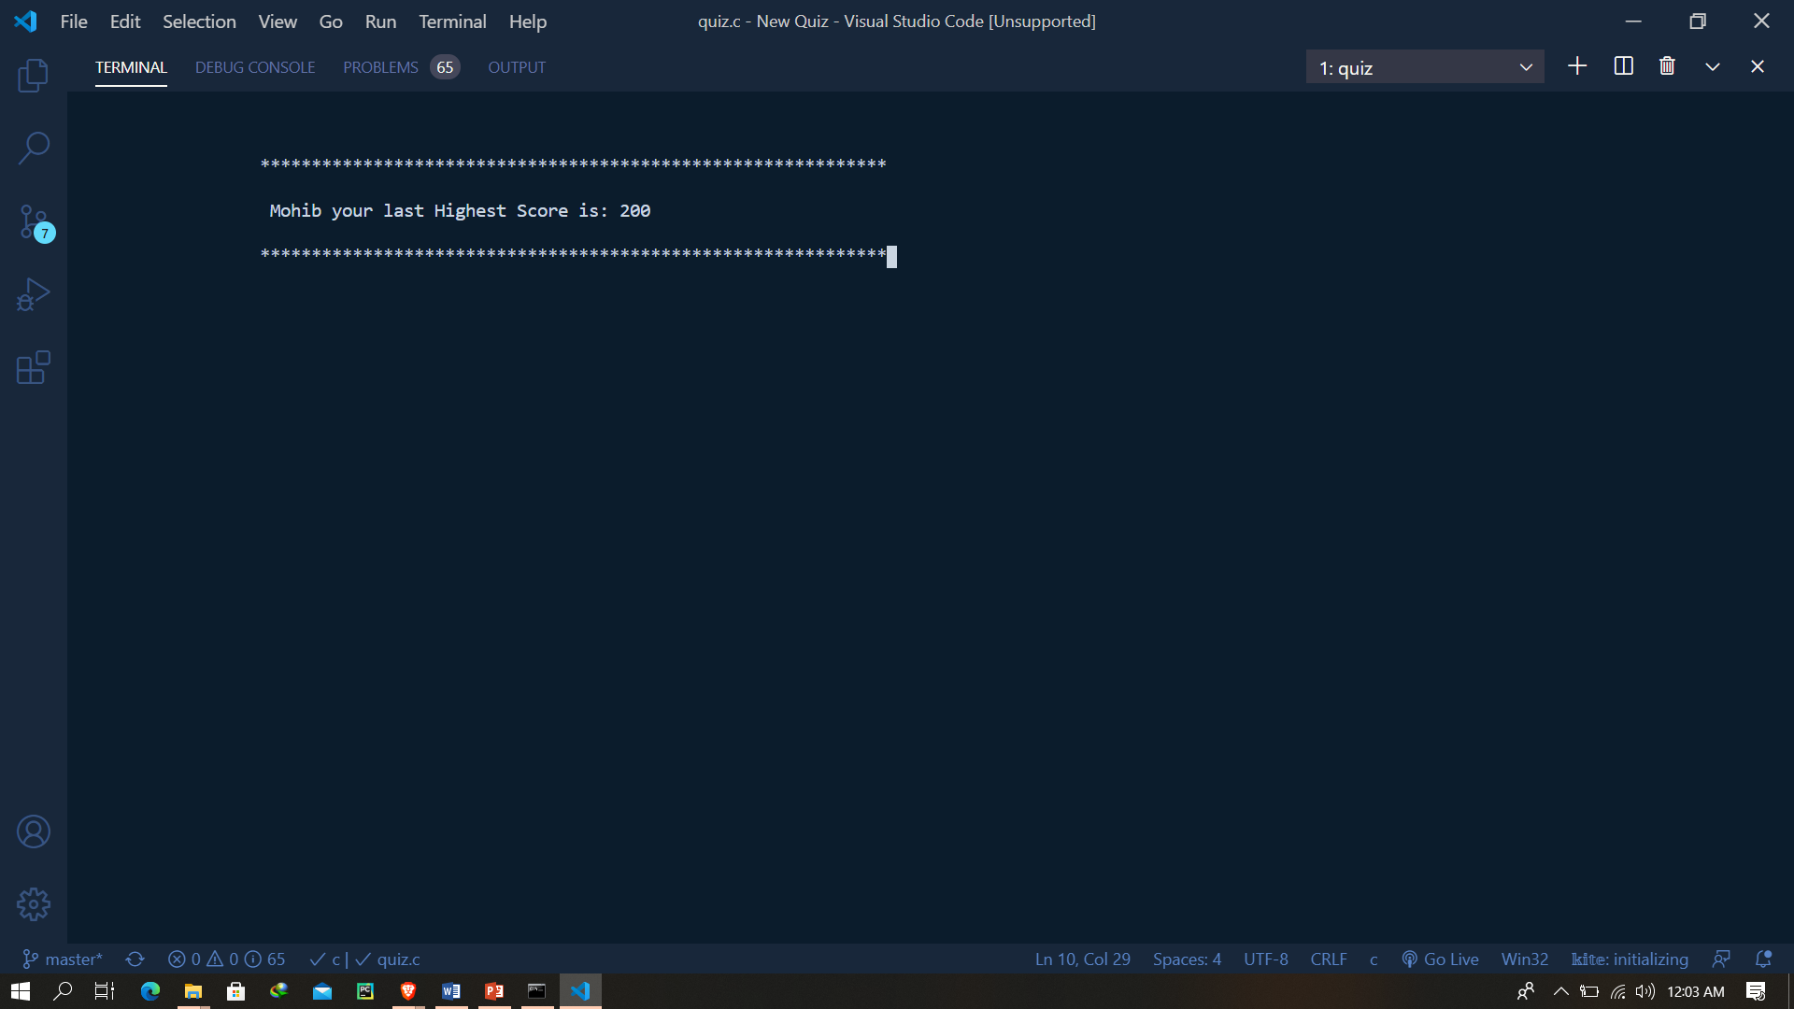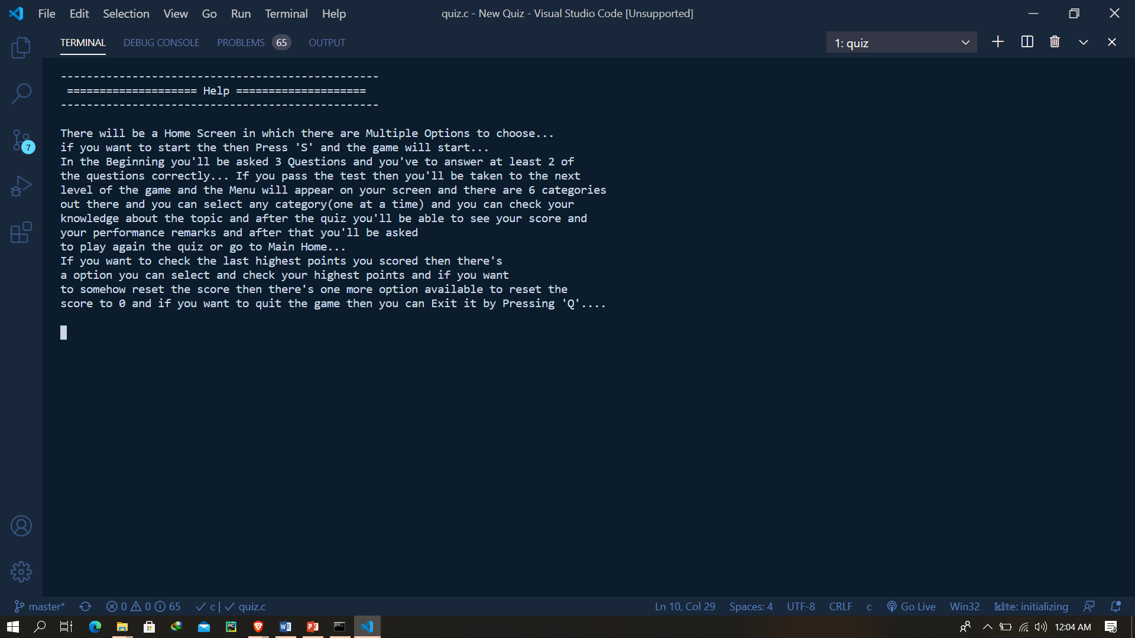

**Task sheet**

*We divided the 4 members of team into two and divided the work. All the categories which will be displayed are done together by Haziq & Hassan & All the functions and other type of content like mock test, reset score, start and end game etc are done together By Mohib and Arbaz.*

**Flowchart**

